Direct Business Wholesale Invoice Renaming

We are renaming two types of Invoices for Direct Business Wholesale

1. Membership
2. Sales Ledger

# Membership

Put all membership invoices on below location (Only .pdf files)

\\clbnas01\prioritypass\8A. OPS WHOLESALE (inc Lite & Affinity)\Monthly Reports\Billing Automation project\Invoices

Click below link (this will open automatically on Internet explorer), if you open it first time for day then it will ask for username and password which is same as your system login

[Gallery](http://10.204.210.202:1433/gallery/#!app/DB---Rename-Invoices-Membership/6388ba157954d6c522fcf119)

Click on RUN button on right corner in Red  
  
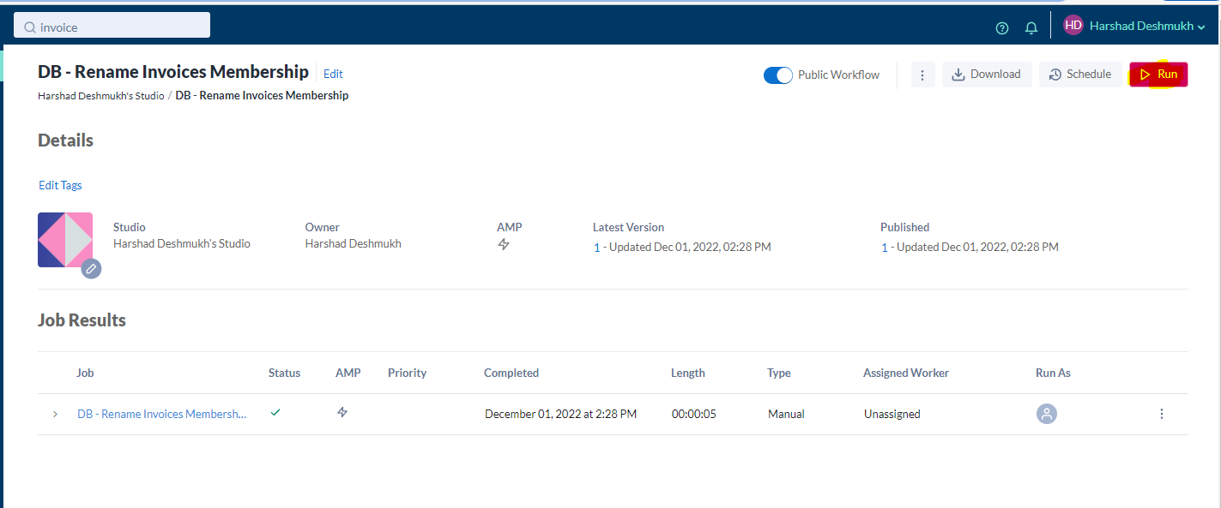  
  
After successful execution it will show Status like below which mean files renamed on same location

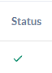  
  
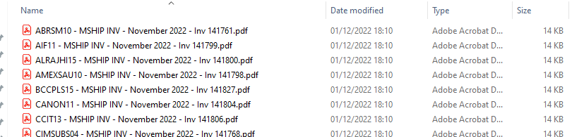

# Sales Ledger

Put all Sales Ledger invoices on below location (Only .pdf files)

\\clbnas01\prioritypass\8A. OPS WHOLESALE (inc Lite & Affinity)\Monthly Reports\Billing Automation project\Invoices

Click below link (this will open automatically on Internet explorer), if you open it first time for day then it will ask for username and password which is same as your system login

[Gallery](http://10.204.210.202:1433/gallery/#!app/DB---Rename-Invoices-Sales-Ledger/639701df320c45acc2fbab1a)

Click on RUN button on right corner in Red  
  
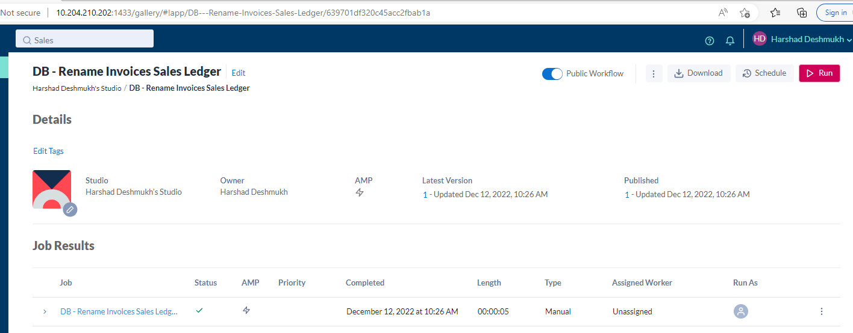  
  
After successful execution it will show Status like below which mean files renamed on same location

  
  
